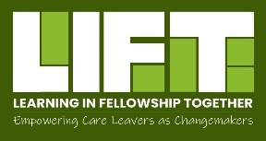
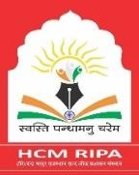

Two Days Event for launching Year 2 Learning in Fellowship Together Program

Day 1
Time | Theme / Sub theme | Resources
9:30 – 10.30 | Registrations
Inaugural
10:30 -11:30 | Welcome and context setting | Dr. Kiran Modi  Founder Managing Trustee  Udayan Care
 | Address by Guests | Ms. Rajesh Yadav (IAS Retd.)  Senior Fellow  Child Resource Centre  HCM RIPA, Jaipur
 | UNICEF | Ms. Sangita Bhatia  National Child Protection Specialist  UNICEF  Mr. Sanjay Nirala  Child Protection Specialist  UNICEF, Rajasthan
 | National Care Leavers Newsletter | Pooja Udayan  Newsletter Core Committee  Surja Chauhan,  Newsletter Core Committee
11: 30 – 12:00 | Tea Break
Graduation and Certification Ceremony
12:00 – 1:00 | LIFT Batch 1 Fellows Speak | Sharing Work and Experiences of Fellows
 |  | Transformation stories
 | Address by Chief Guest | Dr. Samit Sharma  Principle Secretory SJE, GoR
 | Certificate distribution
1:00 – 2:00 | Lunch
Induction Ceremony
2:00 - 4:00 | LIFT Batch 2 Fellows: introduction and induction | Fellows presents their project designs
 | Pledge | Led by Batch 1 fellows and Surja Chauhan
4:00 – 4:30 | Tea Break
4:30 pm | Cultural Activities | Cultural performances
Day 2
10.00 – 10.30 | Recap day 1 | Udayan Care
10.30 – 1.30 | Design Thinking Workshop | - Pooja Khandelwal  Vice President, Genpact  - Rahul Daultani  Asst. Vice President, Genpact  - Shakti Mohan Singh Rathore  Asst. Vice President, Genpact  - Varun Sharma  Asst Vice President, Genpact  - Himmat Singh, Genpact
1:30-2:30 | Lunch
2:30-3:30 | National Care Leavers Network | Ms. Nupur Pande  Aide et Action  Delhi
3:30-4:30 | Appreciative Inquiry Workshop | Ms. Leena Prasad,  Assistant Director  Advocacy, Research, and Training  Udayan Care
4:30-5:00 | Modalities for working and closure | Vidhika Gadia and Surja Chauhan  Programme Coordinators, Care Leavers’ Engagement  Advocacy, Research, and Training  Udayan Care

